ABSTRACT

WebGrabber is a desktop application that downloads Web pages for offline viewing. It can download a page or an entire site easily. It downloads images and other files as well as pages, and adjusts the URLs referenced inside each page that contains HTML to refer to the locally kept pages. You can download an entire directory of images without being able to "see it" . You can use it for ftp downloads.

Web Grabber has the following features:
• Pages are downloaded easily, from a single page to an entire site
• Directory tree on the local machine is created automatically
to match the downloaded site
• URLs that refer to downloaded pages are translated automatically
• Images can be downloaded with pages (this is a settable feature)
• Site configuration can be programmed and stored, accessible later from a menu
• The Web browser can be accessed from the Web Grabber application

This project is developed using C# (.Net) framework on Windows XP platform. We assure that our proposed computerization will be fully benefited to the requirements of the application.

TABLE OF CONTENTS

1. INTRODUCTION 5

2. SYSTEM ANALYSIS
2.1 Introduction 7
2.2 Problem Identification 7
2.3 Requirement Analysis
2.3.1 Hardware Requirements 9
2.3.2 Software Requirements 9
2.4 Scope of the Project 12
2.5 Feasibility study 13

3. SYSTEM DESIGN
3.1 Introduction 14
3.2 Data Flow Diagram 14
3.3 Input Design 19
3.4 Output Design 19
3.5 Database Design 19

4. SYSTEM IMPLEMENTATION AND TESTING
4.1 System Implementation 21
4.2 Testing
4.2.1 Unit Testing 22
4.2.2 Syntax testing 22
4.2.3 Integration Testing 22
4.2.4 Validation Testing 22
4.2.5 Output Testing 22

5. FUTURE SCOPE 23

6. CONCLUSION 24

7. REFERENCES 25

8. APPENDIX 26

1. INTRODUCTION

WebGrabber is a desktop application based on windows platform for downloading websites and browse it when offline. This program can quickly download entire website or part of a site including HTML, graphics, Java Applets, sound and other user definable files ,and saves all the files in the hard drive in their native format. After downloading, all links within the website are reconstructed and creating a complete hard drive copy of the site that you can view at your own place without being connected to the internet. Additionally project should duplicate the original directory structure of a site making it easy to download and transfer a site to another server.
This project is implemented as a software utility which can be installed in the system. The utility can be installed in any system with windows platform.
Downloading web pages and all their supporting files (such as graphic files, sound files, etc.) manually is inconvenient, time consuming and frustrating. Webgrabber addresses these problems by allowing you to download a quantity of information or an entire web site to your hard drive.
Downloading can be done in off peak hours when access lines are available and less expensive. The data may then be edited, browsed, studied, or used in any way offline at your convenience.
This makes the use and modification of the information gathered more economical and efficient. It is simple to use and cost effective for anyone working with web content.

Existing System:

In this modern world internet serves as a means of connecting people all around the world. Today much of the data is transferred by the internet as mails and important information is downloaded from the internet. But people with slow connection may not be able to download the data while many people are online as the connection will be slow as many users are using the same bandwidth. Moreover they will also have to pay money for the extra usage of their connection . There is no way both of this could be done without being on-line. Our proposed system overcome all these disadvantages in an efficient manner giving the client full power to use internet while he is off-line.

Proposed System:

It has the following features.

- Online Browsing

- URL Parsing

- URL Reconstruction

- URL blocking

- URL unblocking

- Offline Browsing

- User Authentication

2.SYSTEM ANALYSIS

2.1 INTRODUCTION
System analysis is the process of determining what needs to be done before how it should be done. In order to accomplish this, one should first refers the existing systems and documents.. After analyzing the data and studying the existing system, the new system is developed.
System analysis is a process of gathering and interpreting parts, diagnosing problems and using the information to recommend improvements to the system. In brief, analysis specifies what the system do. It is the managed technique that leads in designing a new system or improving an existing system. To achieve these things someone must analyse the existing system and articulate the needs for information requirements rests with systems analysis, who provide a liaison between the users, like designer, explaining capabilities and limitation of the CBIS(Computer Based Information System).

2.2 PROBLEM IDENTIFICATION

Existing system:
In this modern world internet serves as a means of connecting people all around the world. Today much of the data is transferred by the internet as mails and important information is downloaded from the internet .manual downloading of websites from the server is time consuming and inefficient.

Limitations of the existing system:
1.People with slow connection may not be able to download the data while many people are online as the connection will be slow as many users are using the same bandwidth.
2. Moreover they will also have to pay money for the extra usage of their connection.

Proposed system:
The proposed system is designed to meet all the disadvantages of the existing system.In the proposed system a number of features are added to the project for the proper functioning of the system. Offline browsing is the important feature of the system. The new system has been proposed to handle the existing functions in more efficient and oderly manner.
Merits/features of the proposed system:
online browser: An online browser is used for retrieving, presenting, and traversing information resources on the World Wide Web. An information resource is identified by a Uniform Resource Identifier (URI) and may be a web page, image, video, or other piece of content
url parsing:
It helps to break down a URL string into its component parts: scheme, host, port, path and query string. The returned information can be used in the WEB OPEN command to open a client connection to the host named in the URL.

url blocking and unblocking:
The administrator can restrict the website access by blocking and unblocking feature.

offline browser:
The offline browser is used to view the downloaded files from the computer hard disk.

2.3 REQUIREMENT ANALYSIS

A Software Requirements Specification (SRS) – a requirements specification for a software system – is a complete description of the behavior of a system to be developed. It includes a set of use cases that describe all the interactions the users will have with the software. In addition to use cases, the SRS also contains non-functional (or supplementary) requirements. Non-functional requirements are requirements which impose constraints on the design or implementation (such as performance engineering requirements, quality standards, or design constraints).

2.3.1 HARDWARE REQUIREMENTS

Microprocessor : Intel core i3
RAM : 4 GM
Hard disk : 500 GB
Keyboard : Standard Notebook Keyboard
Display : 14’6 LCD

2.3.2 SOFTWARE REQUIREMENTS

Operating System : Windows based OS
Front end : .NET
Back end : SQL server 2008

SOFTWARE SELECTION:

Software selection is a critical aspect of system development.. Software must be selected in accordance with the application.
The criteria for selecting a software is
• Productivity of the language (including tools - IDE, debugger, etc) .
• Employable set of people who have that particular language skills .

• "popularity" of the language .
• People in your organization who have the language skills .
• Difficulty in learning the language .
• Portability of the language/platform support .
• Applicability to the problem domain.

MICROSOFT .NET

.NET technology was introduced by Microsoft, to catch the market from the SUN's Java. Few years back, Microsoft had only VC++ and VB to compete with Java, but Java was catching the market very fast.The .net framework is a new computing platform that simplifies application development in the highly distributed environment. It supports many programming languages, including VB.NET, C# etc. The .NET Framework's Base Class Library provides user interface, data access, database connectivity, cryptography, web application development, numeric algorithms, and network communications. Programmers produce software by combining their own source code with the .NET Framework and other libraries. The .NET Framework is intended to be used by most new applications created for the Windows platform. Microsoft also produces a popular integrated development environment largely for .NET software called Visual Studio. Silverlight is a part of .NET Framework.

The .net framework has two main components:
The common language runtime and the .net framework class library. The common language runtime is the foundation of the .net framework. Runtime manages code at execution time, providing core services such as memory management and thread management while also enforcing strict type safety and other forms of code accuracy that ensures security and robustness. In fact the concept of code management is a fundamental principle of the runtime. The main component of the .net framework is a comprehensive object oriented collection of reusable types that can be used to develop applications ranging from traditional command line or graphical user interface (GUI application).

VISUAL STUDIO .NET:

Microsoft Visual Studio is an integrated development environment (IDE) from Microsoft. It can be used to develop console and graphical user interface applications along with Windows Forms applications, web sites, web applications, and web services in both native code together with managed code for all platforms supported by Microsoft Windows, Windows Mobile, Windows CE, .NET Framework, .NET Compact Framework and Microsoft Silverlight.
Visual Studio includes a code editor supporting IntelliSense as well as code refactoring. The integrated debugger works both as a source-level debugger and a machine-level debugger. Other built-in tools include a forms designer for building GUI applications, web designer, class designer, and database schema designer. It accepts plug-ins that enhance the functionality at almost every level—including adding support for source-control systems (like Subversion and Visual SourceSafe) and adding new toolsets like editors and visual designers for domain-specific languages or toolsets for other aspects of the software development lifecycle (like the Team Foundation Server client: Team Explorer).
Visual Studio supports different programming languages by means of language services, which allow the code editor and debugger to support (to varying degrees) nearly any programming language, provided a language-specific service exists. Built-in languages include C/C++ (via Visual C++), VB.NET (via Visual Basic .NET), C# (via Visual C#), and F# (as of Visual Studio 2010). Support for other languages such as M, Python, and Ruby among others is available via language services installed separately. It also supports XML/XSLT, HTML/XHTML, JavaScript and CSS. Individual language-specific versions of Visual Studio also exist which provide more limited language services to the user: Microsoft Visual Basic, Visual J#, Visual C#, and Visual C++.

SQL SERVER :
SQL server aims to make data management self-tuning, self organizing, and self maintaining with the development of SQL Server Always On technologies, to provide near-zero downtime. SQL Server 2008 also includes support for structured and semi-structured data, including digital media formats for pictures, audio, video and other multimedia data. In current versions, such multimedia data can be stored as BLOBs (binary large objects), but they are generic bitstreams. Intrinsic awareness of multimedia data will allow specialized functions to be performed on them.SQL Server 2008 can be a data storage backend for different varieties of data: XML, email, time/calendar, file, document, spatial, etc as well as perform search, query, analysis, sharing, and synchronization across all data types

2.4 SCOPE OF THE PROJECT:
The scope of a project outlines the utility of the project. It lists out the targeted audience and how the project is to benefit them more than the existing system.
Webgrabber can be used in a home/company to download and save a website so that they can be used even when an internet connection is not available. Also , images and videos stored in the server can also be downloaded and a copy can be kept so that when the need arises , we can just look it up and not bother about whether an internet connection is available or not.
Another targeted audience is the student community. Students can use this to download study materials and store them in their computers and use them as and when they are required without bothering whether an internet connection is available or not. This can be extended to schools and colleges also. Once a tutorial site is downloaded students can browse through it offline instead of going online every time he / she needs.

2.5 FEASIBILITY STUDY

It is carried out to select the best system that meets performance requirement. These entails identification, classification and evaluation of candidate systems and selection of the best system for the job.
This project is feasible in all means both economically and legally. The project development has no extra expenditure. All development tools used are licensed products. Everybody can utilizes the services provided by this product by installing the software.

3.SYSTEM DESIGN

3.1 INTRODUCTION

The most creative and challenging phase of the system life cycle is system design.
also included the construction of program and testing.

The design phase focuses on the detailed implementation of the system recommended in the feasibility study. The design phase is a transition from a user-oriented document to a document oriented to the programmers or database personnel. Systems design goes through two phases of development:

- Logical Design
- Physical Design

The data flow diagram shows the logical flow of a system and defines the boundaries of the system. For a candidate system, it describes the inputs (source), outputs (destination), database (files) and procedures (data flow), all in a format that meet the user's requirements. In logical design we specify the user’s needs at a level of detail that virtually determines the information flow into and out of the system and the required data resources.

3.2 DATAFLOW DIAGRAM

Data flow is one of the best ways of documenting the entire functionality of the system. For any system, which will have some data flows in and have some processing inside and then some data flows out from the system, which has inputs,

process and outputs. Once any system is represented using a data flow diagram, we can identify the following things easily:

- Various entities interacting with the system are identified.
- Flow of data from one entity to another entity is identified.
- The various processes involved in between the interaction of two or more entities
in the system are clearly pointed out.
- The various data stores, which hold the data in between the processes, are clearly
identified.

There are various symbols used in a dataflow diagram. Bubbles represent the processes. Named arrows indicate the data flow. External entities are represented by rectangles and are outside the system such as vendors and customers with whom the system interacts. They either supply or consume data. Entities supplying data are known as source and those that consume data are known as sinks.

Dataflow diagrams can be hierarchically organized, which help in partitioning and analyzing large systems. As a first step, one data flow diagram can depict an entire system, which gives the system overview. It is called Context diagram or level0 DFD.

The Context diagram can be further expanded. The successive expansion for DFD from the Context diagram to those giving more details is known as leveling of DFD. Thus a top down approach is used. Starting with an overview and working with the details.

The main merit of DFD is that it can provide an overview of what data a system would process, what transformation of data are done, what files are used, and where the results flow. Context level DFD was drawn first. Then the processes were decomposed into several elementary levels and were represented in the order of importance.

BASIC DFD SYMBOLS
A data flow is a route, which enables packets packets of data to travel from one point to another. Data may flow from a source to a processor and from data store

to process. An arrow line depicts the flow, with arrow head pointing in the direction of the flow.

A process represents transformation where incoming data flows are changed into outgoing dataflow.

A source or sink is person or part of an organization which enters or receives information from the system, but is considered to be outside the context of data flow model.

Data store symbol, represented by open boxes. Arrows entering (exiting) open boxes represent data that are inserted into(extracted from) the data store.

DATAFLOW DIAGRAM

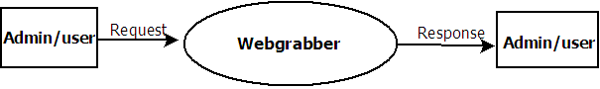

Level 0 DFD

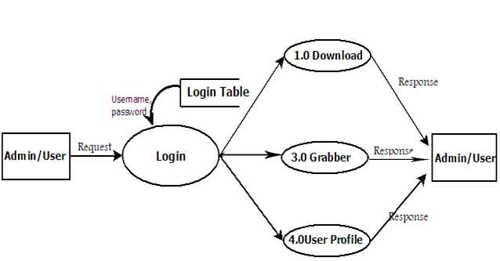

Level 1 DFD

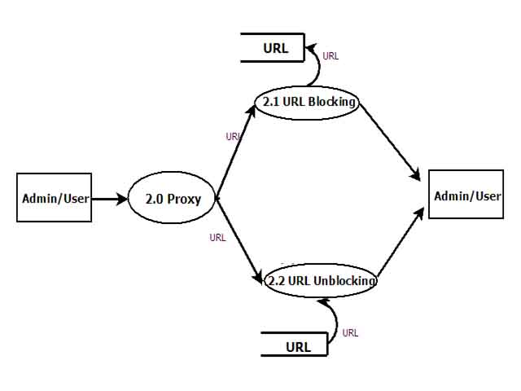
Level 2 DFD

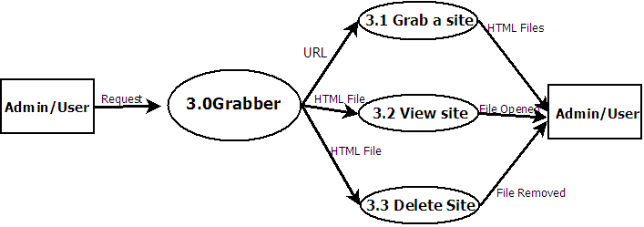

Level 2 DFD

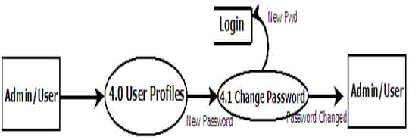

Level 2 DFD

3.3 INPUT DESIGN

In the input design the user-oriented input are converted into computer recognizable format. In the input system data is accepted and it can be readily used for data programming or can be stored in database for further use
The objectives of input design are as follows:
- Controlling the input
- Avoiding errors in the data
- Reaping the process simple
- Avoiding extra steps

3.4 OUTPUT DESIGN

The output design provides maximum possible information to the user according to their needs.Output design is the ongoing activity,started during the study phase itself.The objective of the output design is to design the contents and format of the various outputs generated in the form of “reports”. Basic reasons for report generation are
- To help in the purpose of communication of information to the user
- To provide permanent storage

3.5 DATABASE DESIGN

The Product entitled “WEBGRABBER” uses a database named ‘database1’ which is created in SQL 2008.The database has two tables LOGINTABLE and URLFORM.
LOGINTABLE is using for storing the information of users and URLFORM is
Using for url blocking and unblocking.

TABLE DESIGN

Fields | Datatypes | Constraints
Username | Varchar() | Not null
Password | Varchar() | Not null

Table 1. login table

Fields | Datatypes | Constraints
Url | Varchar() | Not null

Table 2. urlform
.

- SYSTEM IMPLEMENTATION AND TESTING

4.1 SYSTEM IMPLEMENTATION

Implementation is the process of bringing and developing operational use and turning it over to the user. Implementation activities extend form planning through from the old system to the new.
Implementation of the new system involves three major steps- training of the administrator who may interact with the system, conversion of the old system to the new system and post implementation review.
Software has been tested for smoothness and user friendliness. Any person with computer knowledge can operate the system. The only training required is to explain the various features of the system and how to use it.
The next step is the implementation conversion. Conversion is the process of performing all the operation that directly results in the turnover of the new system into operation. At first both the new system and existing system were operated in parallel. Use of the new system would not cause disastrous effects.

4.2 TESTING

Testing is the process for ensuring the correctness by finding erro. A good test case is the one that has high probability of finding an error. If a testing is conducted successfully, it will uncover error in the software. As a secondary benefit, testing demonstrates that software function appears to the working according to the specification that behavioural and performance requirements appear to have met. A system is tested for online response volume of transaction, stress, recovers from failure and reusability.

4.2.1 UNIT/COMPONENT TESTING

Unit testing is a test of sample piece of code that is the smallest piece of code testable.

4.2.2 SYNTAX TESTING

We use system testing to eliminate error in software. For retrieving particular sites for browsing user should enter correct url,for the better performance user should specify internet protocol.

4.2.3 INTEGRATION TESTING

Two approaches are used to for integration testing in the context of object oriented system. Thread based testing integrates the set of class of required response to one input or event for the system. Each thread is integrated and tested individually. The second integration approach is use-based testing. It begins the construction of the system by testing of independent classes.

4.2.4 VALIDATION TESTING

Like conventional validation, the validation of the software focuses on user visible action and user recognizable output from the system. The purpose of system testing is to identify and correct errors in the candidate system.

4.2.5 OUTPUT TESTING

In these phase, each program module is checked for two types of errors-syntax and logic. A syntax error is a program statement that violates one or more rules of the language, visual basic .NET. A logic error deals with correct data fields, out of ranges
items and invalid combination. Thus each and every program statement is tested to check whether the expected output is ahead.

5. FUTURE SCOPE

Almost every project is subjected to change depending on the client’s requirements. The system and the architecture of our software is a compatible one, so addition of new modules can be done without much difficulty.

- Our software is designed to work in WINDOWS XP platform.One of the main enhancements needed is to provide compatibility with LINUX OS.
- Downloading is limited to files such as graphic,sound etc, we propose to extend this by downloading flash contents from a site.
- For the convenience of user, time implementation can be included .

6.CONCLUSION

The software package developed has advantages. The biggest advantage of the system is user friendliness, because the entire application is menu driven so that a newcomer can also use the software efficiently. We have tried our maximum to develop a system that is error-free and easy to use.
The areas of computer applicants are numerous. This project is implemented as a software utility .The utility aims in helping a user with enabling offline browsing.,downloading can be done in off peak hours,when access lines are available
and less expensive and this makes the use and modification of the information gathered
more economical and efficient.It is simple to use and cost effective for anyone working with web content.

7.REFERENCES

TEXT BOOKS

- Fundamentals of Software Engineering
- Carlo Ghezzi, Mehdi Jazayeri, Dino Mandrioli

WEBSITES

- www.dotnetspider.com/tutorials
- www.wikipedia.org
- www.computerworld.com
- www.sourcecodesworld.com

APPENDIX
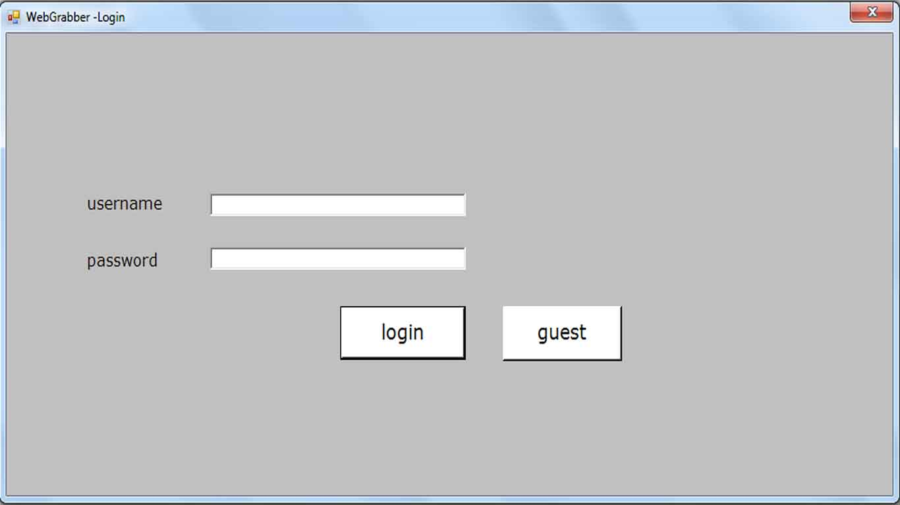
LOGIN PAGE

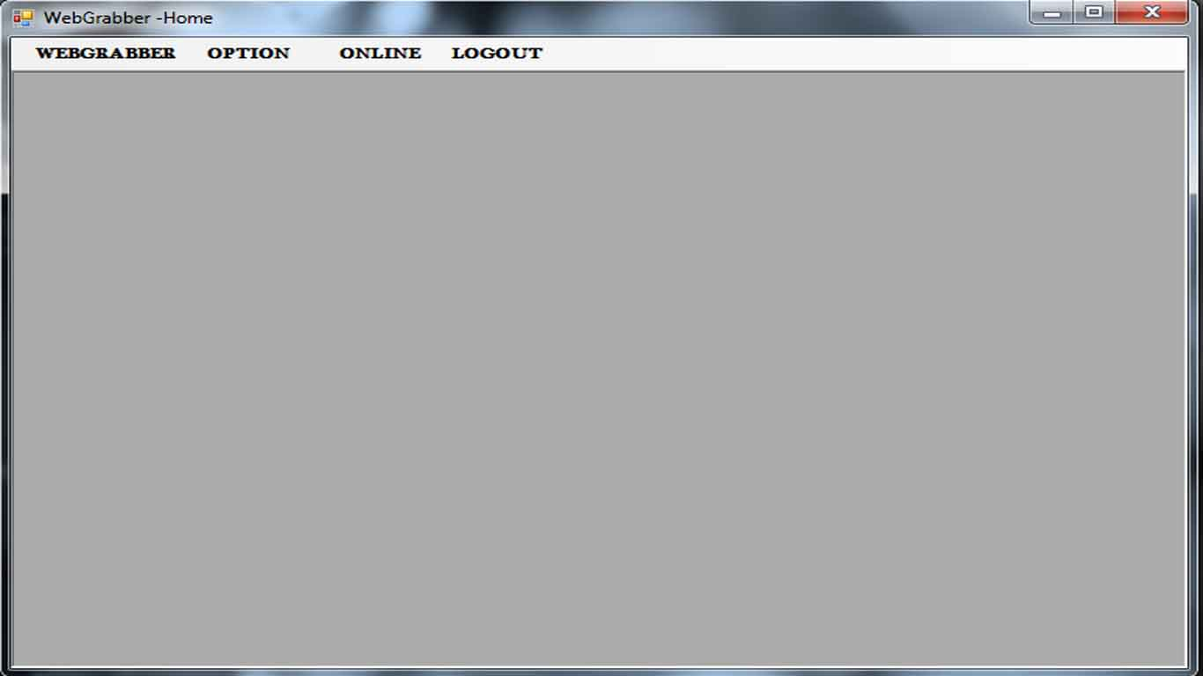
HOMEPAGE
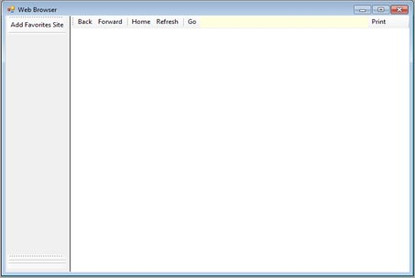
ONLINE BROWSER

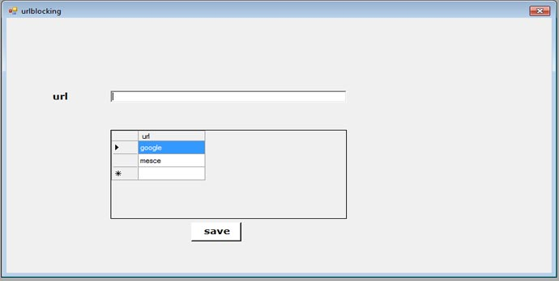
URL BLOCKING

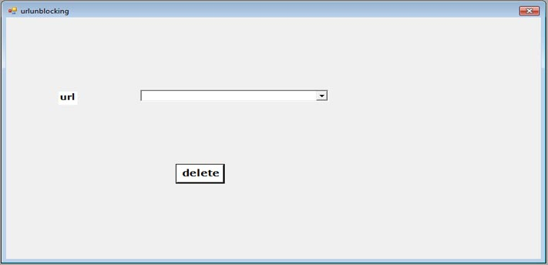 URL UNBLOCKING

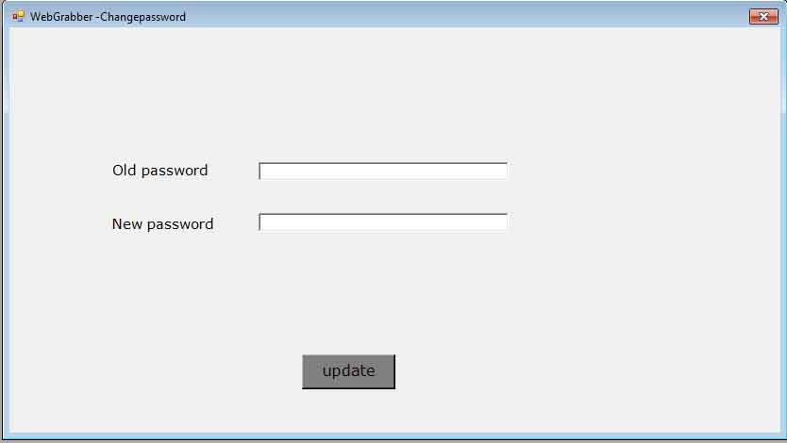
CHANGE PASSWORD

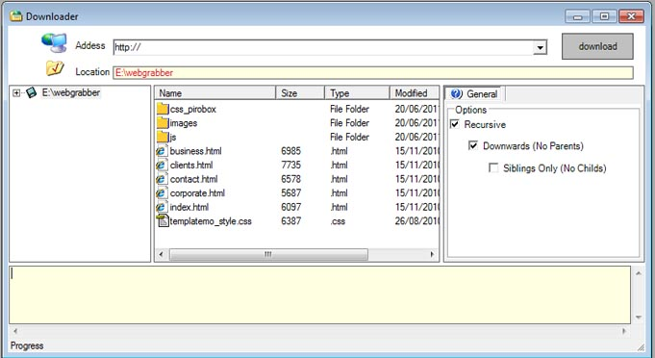
WEB GRABBER

